**RStudioServer Help**

**To Log in (on campus or using VPN):** [http://turing.cornellcollege.edu:8787](http://turing.cornellcollege.edu:8787/auth-sign-in?appUri=%2F)

* Add link to Moodle for students

**To Install packages to all users**

* Log into RStudioServer
* Open terminal tab in lower left pane
* Use command
  + sudo R
    - It may ask for your password, type it in
    - This starts with admin privileges
* Use regular R commands to install packages
  + install.packages(“PACKAGE”)

**Changing passwords (include in your notes or give out to students so they can change whenever)**

1. Need to click “Terminal” tab in top/bottom left
2. Type “passwd”
3. Follow prompts. Their new password has to be longer than 8 characters and different from their previous.

Instructor Change to Students Password

* + Use command: sudo passwd ***their_user_name***
  + it may prompt you for instructor password, enter it and click enter
  + then you type their new password and click enter

**Other useful tips with RStudioServer**

* Their R sessions remain open after they leave and comeback (usually even unsaved changes!)
* When typing passwords in the terminal, typed characters will appear blank (no little stars)
* The usernames in RStudioServer are cap sensitive. It may be useful to bring the list of emails that are used to create the accounts to class so students don’t have to remember the caps of their emails.
* If R get stuck or something isn’t working
  + Save all files, click the power button icon in the top right corner

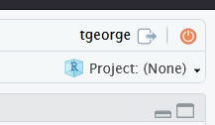

**Moving and accessing a datasets to/on server**

1. Click the Files tab in the lower right panel in RStudioServer.
2. Click “Upload”
3. Target directory (this is where you want the uploaded files to go)
   * Click “Browse” and then click the “datasets” folder and click “choose” on the bottom right
4. File to upload: Click “Browse” and locate the file you wish to upload. Finally choose “OK” and your data file should now be in the dataset folder on the virtual machine.
   * If you want to move over lots of data at once, on your Windows computer zip them into a folder. Then upload that zipped folder. It will automatically unzip.
   * All students should immediately see the dataset. If not how them click the circled icon:

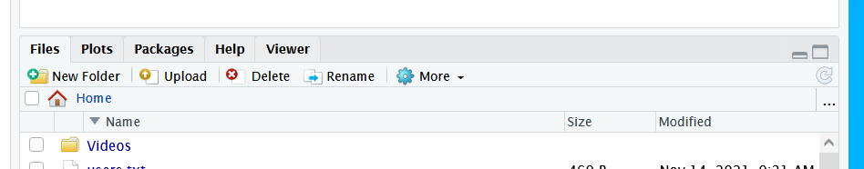

* If using an RProject, if you don’t want to have the student change working directory to access data, the dataset needs to be copied into their folder.
  + This will crate a lot of duplicated datasets but if it easier that that is fine.

**Collecting Student Work**

* If using RMarkdown, their htm files will open in their browser, they can file save as their local machine (using their browser) or print.
* If you want them to send you a script, the easies is actually to have them save it in a folder that you have access to and they only have written asses too.

**Test student account for R Stuff:**

* stats_test
* password: abc123

**Creating Student Accounts**

* Ajit has a made a script for this
  + The script looks for a file named “users.txt” that is a basic text file with student emails and an enter after each email. This file needs to be in the same folder as the script being run
  + The script first needs transferred to a folder on the vm (using transfer file code below)
  + Next, the script needs to be made executable (command below)
  + The text file of emails needs to be transferred to the vm to the same folder (command below)
  + Lastly the script needs run. Command below.
  + instead of using Linux commands to transfer files, Rstudio upload button can be used
  + The default passwords it uses is abc123
  + The script adds all users created this way to “students” group

**Commands can be used once you are in RStudioServer by clicking the “terminal” tab on the bottom left pane**

* Change Students Password
  + sudo passwd ***their_user_name***
  + it may prompt you for your password, enter it and click enter
  + then you type their new password and click enter
* Create a folder on the Linux machine
  + mkdir ***folder_name***
* Change folder permissions
  + Example where owner has read/write and other only can read
  + *sudo chmod -R 740 /home/****tgeorge****/****foldername***
  + Note: this did not allow others to see the folder though since it was on the sudo account. Extra steps were needed.
* Moving Files
  + *Scp* ***filename*** *connect:****endingdirectory***
* Create group
  + *Sudo addgroup* ***groupname***
* Create user
  + *Sudo useradd -m -p* ***username***
* Remove file
  + *Rm* ***filename***
* Make a file executable
  + *Chmod +x* ***filename***
* Run an executable file
  + Type directly and click enter. If it is on your home directly you just need to give the script name and click enter. It needs to already be executable.
* Display all users
  + *Compgen -u*
* Display all groups
  + *Compgen -g*
* Remove a user and their files
  + *Sudo deluser --remove-home* ***theirusername***
* See a users files
  + *Sudo su user*
* Add a symbolic link
  + *Sudo ln -s* ***directory_to_link******shortcut_location***
* Add user into group
  + *Sudo adduser* ***username groupname***
  + *sudo usermod -a -G* ***groupname username***
* Completely froze session – reset student session
  + [*https://support.rstudio.com/hc/en-us/articles/218730228-Resetting-a-user-s-state-on-RStudio-Workbench-RStudio-Server*](https://support.rstudio.com/hc/en-us/articles/218730228-Resetting-a-user-s-state-on-RStudio-Workbench-RStudio-Server)
  + Choose which directory or directories to rename , via the command

sudo mv /home/**user1**/.local/share/rstudio /home/**user1**/.local/share/**rstudio-old**